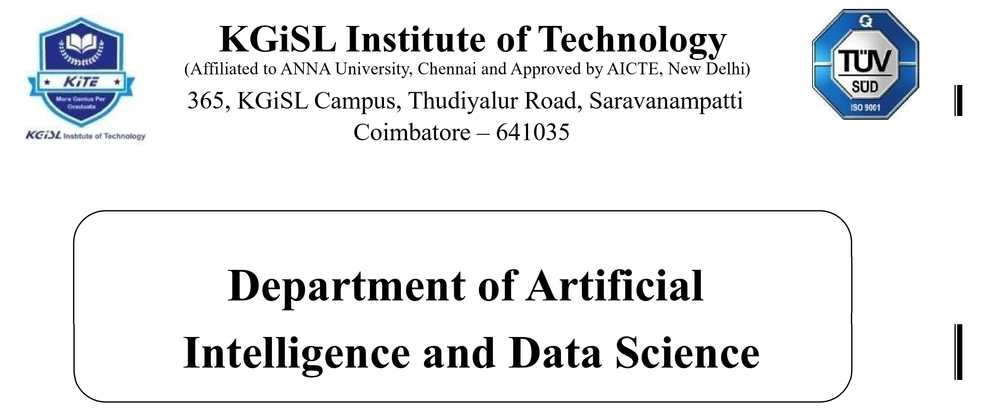

Naan Mudhalvan -IOT

# Problem Statement: SMART WATER MANAGEMENT

MENTOR NAME: EVALUATOR NAME:

Mr.MOHANKUMAR.M Ms.AKILANDESWARI.M

**Smart Water Management  
  
Introduction**

Water, an indispensable resource for life and various human activities, faces escalating demand due to factors like population growth, urbanization, and industrial expansion. This surge in demand, exacerbated by the impact of climate change, has raised significant concerns about water scarcity and the urgency for effective water resource management. In response to these pressing challenges, the concept of "Smart Water Management" has emerged as a holistic and technology-driven approach aimed at optimizing water resource utilization.

Smart water management refers to the use of advanced technologies, data analytics, and innovative strategies to efficiently and effectively manage water resources, distribution systems, and wastewater treatment processes. The primary goal of smart water management is to ensure the sustainable and responsible use of water while minimizing waste, reducing costs, and enhancing the quality and availability of water for various purposes.

Smart Water Management encompasses a comprehensive strategy that harnesses cutting-edge technologies and data-driven insights to monitor, regulate, and enhance the entire water cycle. This encompasses everything from the sources of water to its consumption and wastewater treatment. The overarching goal is to tackle a range of water-related issues, including scarcity, ensuring water quality, improving distribution efficiency, and promoting environmental sustainability.

**System Overview**

Smart water management is a comprehensive and technology-driven approach to optimize the utilization of water resources, ensuring efficiency, sustainability, and quality throughout the entire water cycle. This system is designed to address the pressing issues of water scarcity, quality assurance, distribution efficiency, and environmental responsibility.

Data Collection and Monitoring: The system employs a network of sensors and monitoring devices to collect real-time data on various parameters, including water quality, flow rates, pressure, temperature, and more. These sensors are strategically placed throughout the water infrastructure.

Data Analysis and Decision-Making: Collected data is subjected to advanced data analytics, machine learning, and modeling techniques. This analysis provides insights into water usage patterns, identifies anomalies, and aids in predictive decision-making.

Control and Automation: Automation systems enable remote control of valves, pumps, and other components based on real-time data and predictive analytics. This ensures the efficient distribution of water and minimizes energy consumption.

Leak Detection and Asset Management: Smart water systems use acoustic sensors, pressure sensors, and hydraulic modeling to detect leaks and assess the condition of water distribution infrastructure. This enables timely maintenance and repairs.

Customer Engagement: Consumers are provided access to their water usage data through user-friendly interfaces such as web portals and mobile apps. This encourages responsible consumption and conservation.

Security and Privacy: Robust security measures, including encryption and access control, are in place to protect sensitive data and ensure compliance with data protection regulations.

Integration with Other Systems: Smart water management systems can integrate with other smart city infrastructure components, such as transportation and energy systems, for more holistic urban management.

Environmental Sustainability: The system promotes sustainable practices, including water reuse and rainwater harvesting, to minimize environmental impact and resource wastage.

Compliance and Reporting: Compliance with water quality regulations and environmental standards is facilitated, with records maintained for regulatory reporting.

Continuous Improvement: Regular monitoring, data analysis, and insights from historical data enable ongoing improvements in water management strategies and infrastructure maintenance.

**objective**

To reduce water waste and encourage sustainable water consumption habits, encourage consumers and businesses to utilize water responsibly.

Distribution of water resources should be optimized for equity of access, to minimize leakage losses, and to use less energy during pumping and distribution.

Water Quality Assurance: Through monitoring and managing water treatment procedures, make sure that the water delivered to customers complies with legal requirements for quality and safety.

Utilize real-time data and analytics to make data-driven decisions about the distribution, treatment, maintenance, and allocation of resources for water.

Leak detection and infrastructure upkeep: To minimize water loss and increase the lifespan of water distribution systems, early leak detection, infrastructure evaluations, and proactive maintenance are necessary.

Resilience to Natural Disasters: By putting early warning systems and disaster preparedness measures in place, you can improve your ability to react to emergencies and natural disasters (such floods and droughts).

Environmental Sustainability: To lessen the influence on the environment, encourage sustainable water management techniques such water recycling, rainwater collection, and ecosystem preservation.

Customer engagement: Give customers access to their water usage information and give them tools to promote sensible usage and conservation.

Compliance and Accountability: Assure adherence to environmental and water quality standards, and keep records for regulatory reporting.

Reduce operational expenses for water utilities by allocating resources effectively, using less energy, and extending the lifespan of infrastructure.

Monitoring and evaluating the effectiveness of water management systems on an ongoing basis will help you find areas where they may be optimized.

**IOT Sensor design**

Ultrasonic flow sensors: These devices calculate the velocity of ultrasonic waves as they travel through water to determine the water's flow rate.

Measure the flow rate of conductive fluids like water using magnetic flow sensors (magmeters), which operate on the electromagnetic induction principle.

a pressure sensor

Piezoelectric pressure sensors: monitor water pressure levels and spot anomalies by measuring pressure variations in water distribution systems.

Detectors of water quality:

pH sensors: Measure the water's acidity or alkalinity to determine whether it needs to be treated.

Water clarity and potential contaminants can be determined by using turbidity sensors, which identify suspended particles and sediments in the water.

Chlorine sensors: Keep an eye on the amount of chlorine in the water to make sure the disinfection procedures are working.

level detectors

**Platform Components:**

1. Data Sensors and Collection:

- Flow meters, pressure sensors, and water quality sensors deployed throughout the water distribution network.

- Data loggers and telemetry systems to collect and transmit real-time data.

2. Data Aggregation and Integration:

- Centralized data platform to aggregate and integrate data from various sensors and sources.

- Compatibility with multiple communication protocols (e.g., LoRa, Zigbee, Wi-Fi, cellular) for seamless data transfer.

3. Visualization and Monitoring:

- User-friendly dashboards and visualization tools for real-time monitoring of water flow, pressure, and quality.

- GIS integration to provide a spatial context for data visualization.

4. Alerts and Notifications:

- Automated alerting system that notifies operators and stakeholders of anomalies, such as leaks or sudden pressure drops.

- Customization alert thresholds and escalation processes.

5. Predictive Analytic:

- Advanced analytic and machine learning algorithms to predict system behavior, detect potential issues, and optimize water distribution.

- Historical data analysis to identify patterns and trends.

6. Control and Automation:

- Capability to remotely control valves, pumps, and other components based on real-time data and predictive analytic.

- Optimization algorithms to adjust water distribution for maximum efficiency.

7. Security and Privacy:

- Robust cybersecurity measures to protect sensitive data and infrastructure.

- Access control and encryption protocols to ensure data privacy.

8. Reporting and Compliance:

- Generate reports for regulatory compliance and environmental monitoring.

- Maintain records of water quality and distribution parameters.

**Key Features and Benefits:**

1. Real-Time Visibility: Operators and stakeholders gain real-time insights into water flow, pressure, and quality, enabling quick response to issues and emergencies.

2. Efficient Resource Allocation: Data-driven decision-making helps optimize the allocation of water resources, reducing waste and energy consumption.

3. Leak Detection: Early detection of leaks and anomalies helps minimize water losses and prevent infrastructure damage.

4. Predictive Maintenance: Predictive analytic identify potential equipment failures, enabling proactive maintenance and reducing downtime.

5. Environmental Sustainability: Efficient water distribution and reduced wastage contribute to environmental sustainability and resource conservation.

6. Cost Savings: Improved efficiency and reduced energy consumption result in cost savings for water utilities.

7. Customer Engagement: The platform can provide consumers with access to their water usage data, promoting responsible consumption and conservation.

8. Compliance Assurance: Easy access to historical data and compliance reports helps water utilities meet regulatory requirements.

integration approach:

1. Identify Key Components and Systems:

- Begin by identifying the critical components, systems, and data sources within the smart water management infrastructure. This includes sensors, control systems, data platforms, and other relevant technologies.

2. Data Standardization and Compatibility:

- Ensure that all components and systems use standardized data formats and communication protocols to facilitate interoperability.

- Common standards such as OPC UA (Unified Architecture) or MQTT (Message Queuing Telemetry Transport) are often used in industrial IoT applications.

3. Centralized Data Platform:

- Implement a centralized data platform or data lake that serves as the core repository for all data collected from sensors, meters, and other sources.

- This platform should be scalable, secure, and capable of handling large volumes of real-time data.

4. Data Integration and Middleware:

- Employ middleware solutions that facilitate data integration by connecting various systems, devices, and databases.

- Middleware platforms can transform, normalize, and route data to the appropriate destinations.

5. API and Connectivity Development:

- Develop Application Programming Interfaces (APIs) or connectors to enable seamless communication between different components and systems.

- Ensure that APIs support both data retrieval and command and control functions.

6. IoT Platforms:

- Utilize IoT platforms or Industrial IoT (IIoT) platforms that offer built-in features for data integration, device management, and real-time analytics.

- These platforms often provide tools for visualizing data and configuring workflows.

7. Geographic Information Systems (GIS) Integration:

- Integrate GIS systems with smart water management to provide spatial context and visualization of data.

- GIS data can be used for mapping the water distribution network, analyzing geographical factors, and optimizing routes for maintenance.

8. Cloud Integration:

- Leverage cloud computing services and cloud-based platforms to host data and applications.

- Cloud integration enables scalability, data redundancy, and accessibility from anywhere.

9. Cybersecurity and Data Privacy:

- Implement robust cybersecurity measures to protect data during transmission and storage.

- Ensure compliance with data privacy regulations and standards, especially when handling consumer data.

10. User-Friendly Dashboards and Visualization:

- Create user-friendly dashboards and visualization tools that consolidate data from various sources into a single interface.

- These tools should enable users to monitor, analyze, and act on the integrated data effectively.

11. Remote Control and Automation:

- Integrate control systems and automation mechanisms that allow remote monitoring and control of water infrastructure components based on real-time data.

12. Mobile Applications and Alerts:

- Develop mobile applications for field personnel and operators to access real-time data and receive alerts and notifications regarding system status or anomalies.

13. Continuous Monitoring and Optimization:

- Continuously monitor the performance of the integrated systems and data flows.

- Regularly evaluate and optimize the integration architecture to adapt to changing needs and technologies.

**Conclusion:**In conclusion, smart water management stands as a beacon of innovation and sustainability in addressing the complex challenges surrounding our world's most precious resource—water. As our global population grows, urbanization spreads, and climate change intensifies, the responsible stewardship of water resources becomes an imperative.

Smart water management offers a multifaceted approach that combines cutting-edge technology, data-driven insights, and proactive decision-making. It aims to optimize the entire water cycle, from sourcing to consumption and treatment, while addressing the critical issues of water scarcity, quality assurance, distribution efficiency, and environmental sustainability.

Through the integration of IoT sensors, data analytic, real-time monitoring, and predictive modeling, smart water management empowers water utilities and stakeholders to make informed decisions, detect anomalies, and respond swiftly to emergencies. It also promotes water conservation, reduces wastage, and contributes to cost savings, thereby making our communities more resilient and environmentally responsible.